

NEW YORK CITY TAXI TRIP DURATION

GROUP MEMBER:

RONAK SOMANI

SIJIA CHEN

AKSHAYKUMAR WANI

ROHIT SHARMA

BHAVNA CHAUHAN

NORTHEASTERN UNIVERSITY

MPS ANALYTICS – WINTER 2019

SUBJECT: ALY 6015 21370 INTERMEDIATE ANALYTICS

INSTRUCTOR NAME: VALERIY SHEVCHENKO

SUBMISSION DATE: March 30, 2019

**ABSTRACT**

The data set consists of information regarding taxi trips in New York City. Information includes coordinates of pickup points, coordinates of drop off points, day of the week, and the duration of the trip. In this Exploratory Data Analysis for the New York City Taxi Trip Duration is completed with tidy R and ggplot2.The goal is to predict how long a taxi trip will take, i.e., the duration of the trip. The data is loaded and cleaned and exploratory visualization of the pickup and drop off locations is done. K-means clustering is then used on the pick-up and drop off coordinates to develop a route feature matrix. A regression model is trained on these features along with data on the pick-up time and the month the trip took place in. The time series analysis deduces the trend in the trip frequency and pick time over the time line.

**INTRODUCTION**

According to the annual INRIX Global Traffic Scorecard, New York City is the third most congested city in the world in terms of traffic and the second worst in the United States. In the last few years, the number of for-hire vehicles operating in the city has grown from 63,000 to more than 100,000. The dataset “New York City Taxi Trip Duration” is from Kaggle. Our goal of choosing this dataset is to predict the duration of taxi rides in NYC based on features like trip coordinates or pickup date and time. The data has 1.5 million training observations and about 630 thousand test observations, combining pickup and drop-off times to show the total number of trips and the total number of passengers in motion at any given time.

The dataset is released by the NYC Taxi and Limousine Commission, which includes pickup time, geo-coordinates, number of passengers, and several other variables. There are three files contained in the whole dataset:

train.csv: the training set containing 1,458,644 trip records

test.csv: the testing set containing 625,134 trip records

sample_submission.csv: a sample submission file in the correct format

In each data file, here is the data dictionary for us to learn about each variable:

Id: a unique identifier for each trip

vendor_id: a code indicating the provider associated with the trip record

pickup_datetime: date and time when the meter was engaged

dropoff_datetime: date and time when the meter was disengaged

passenger_count: the number of passengers in the vehicle (driver entered value)

pickup_longitude: the longitude where the meter was engaged

pickup_latitude: the latitude where the meter was engaged

dropoff_longitude: the longitude where the meter was disengaged

dropoff_latitude: the latitude where the meter was disengaged

store_and_fwd_flag: This flag indicates whether the trip record was held in vehicle memory before sending to the vendor because the vehicle did not have a connection to the server - Y=store and forward; N=not a store and forward trip

trip_duration: duration of the trip in seconds

To analyze this dataset, we follow the steps from data EDA, regression to clustering and time series analysis.

We will firstly study and visualize the original data, then we use clustering, linear regression model and time series methods to provide predictions and insights.

**EXPLORATORY DATA ANALYSIS**

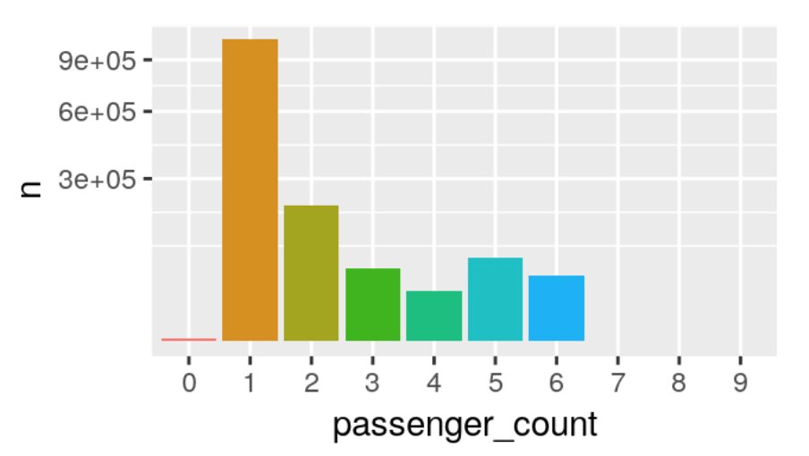

Figure 1: Counts of Passengers per Each Taxi Trip

From Figure 1, the most attractive number is “1” which shows that the most frequent number of passengers per each taxi trip is one passenger. The least frequent number of customers is 7, 8, and 9. These three numbers of customers who take the taxi are exception. The number of 1, 2, 5 are top three counts of passengers regarding New York City taxi. There are a few trips with zero, but it is a rare exception. In general, the count of passengers per each taxi trip varies obviously between 1 and other numbers; from 2 to 6, the trend fluctuates; although 0 is a rare occasion but it does exist.

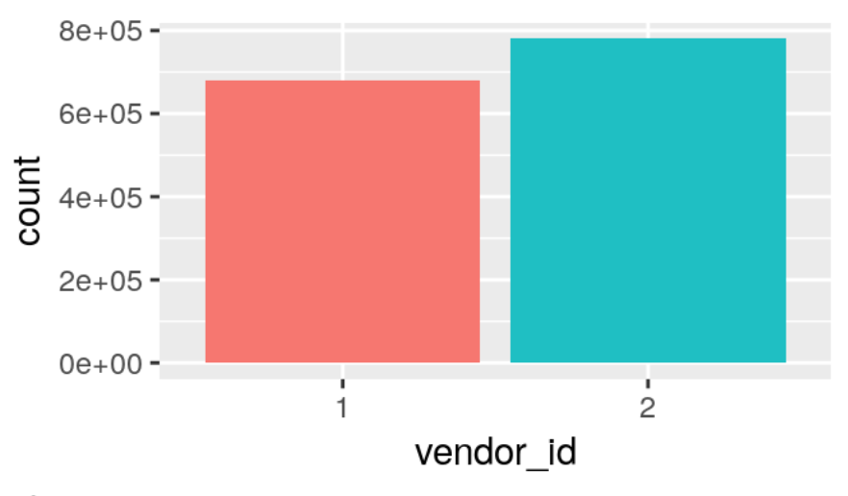

Figure 2: Counts of vendor_id

Figure 2 shows the comparison between vendor_id 1 and 2. “vendor_id” is a code indicating the provider associated with the trip record. From the plot, it could be noticed that vendor 2 has significantly more trips in this dataset than vendor 1.

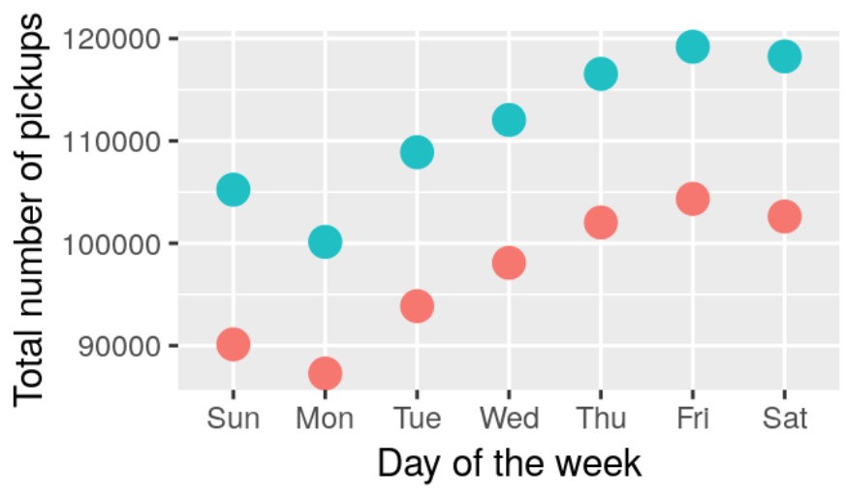

Figure 3: Total Number of Pickups by Day of the Week

Besides, we could see that this trend is also true for Figure 3. In this figure, vendor_id ”1” and “2” show the almost the same trend during a week, with Monday the lowest pickup numbers and Friday the highest pickup numbers. But vendor 2 showing higher number of pickups.

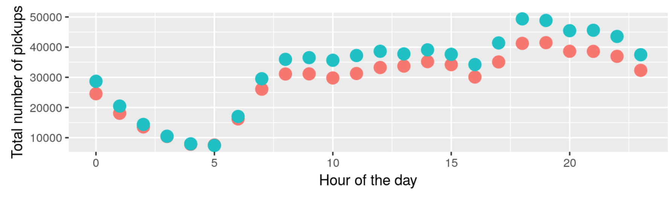Figure 4: Total Number of Pickups by Hour of the Day

Similar pattern between vendor_id “1” and “2” in Figure 4 above can be noticed, with lowest number at 5 am and the highest number at 6 pm. From 5 am to 9 am, there is an increase, because this period is the time when people start going out for work or other things; from 10 to 16, the trend appears to be stable; from 16 to 19, there is another sharp increase, because this period is the time when people are going back home from work or dinner; and from 19 to 24, the number gradually goes down. Generally speaking, this trend reflects the normal living pace of people in New York City.

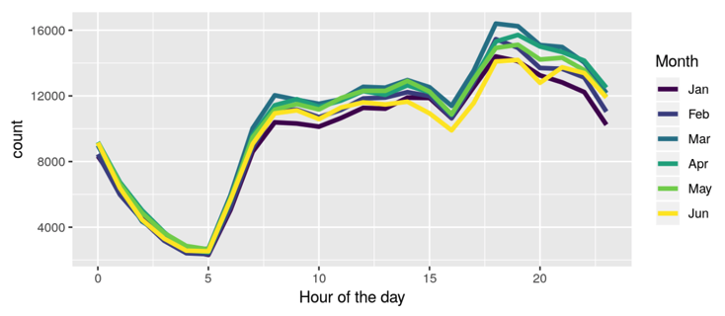

Figure 5: Count of pickups by month

Figure 5 presents the trend that for 6 months, the pickup counts are in the similar shape. Although the pickup counts divided by each hour of the day fluctuated a lot, the difference among months are not large. If we draw a specific conclusion from Figure 5, it would be that January and June have fewer trips, whereas March and April are busier months. This tendency is observed for both vendor_ids.

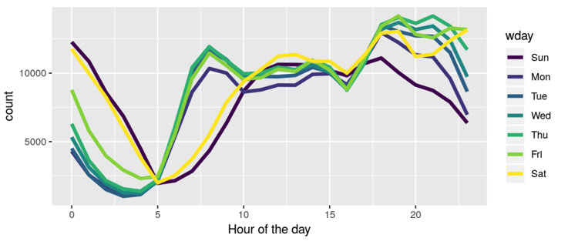

Figure 6: Count of pickups by weekday and weekends

Figure 6 shows that the weekends (Saturday and Sunday, plus Friday to an extend) have higher trip numbers during the early morning hours but lower ones in the morning between 5 and 10, which can most likely be attributed to the contrast between NYC business days and weekend night life. In addition, trip numbers drop obviously on the Sunday evening/night. And it could also be noticed that from Monday to Friday, the count from 5 to 10 increases more dramatically and from 19 to 24 decreases more quickly.

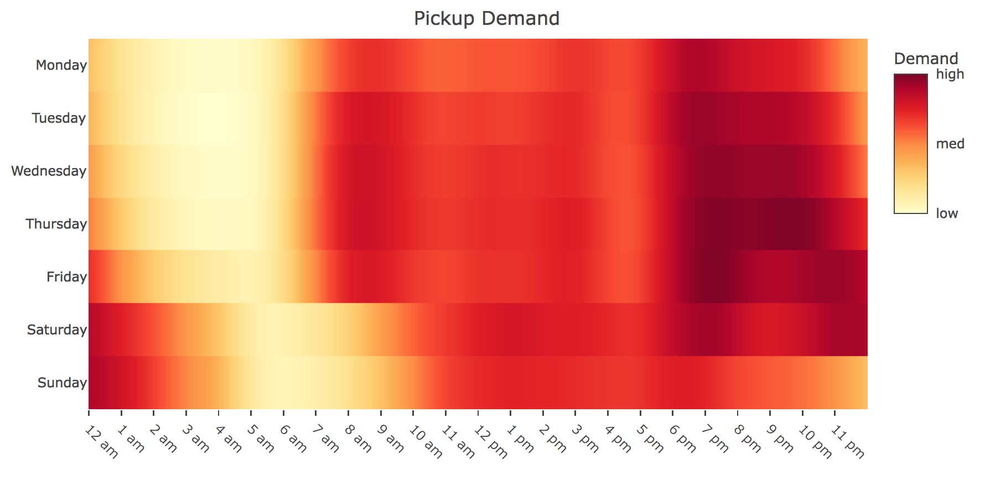

Figure 7: Pickup Demand

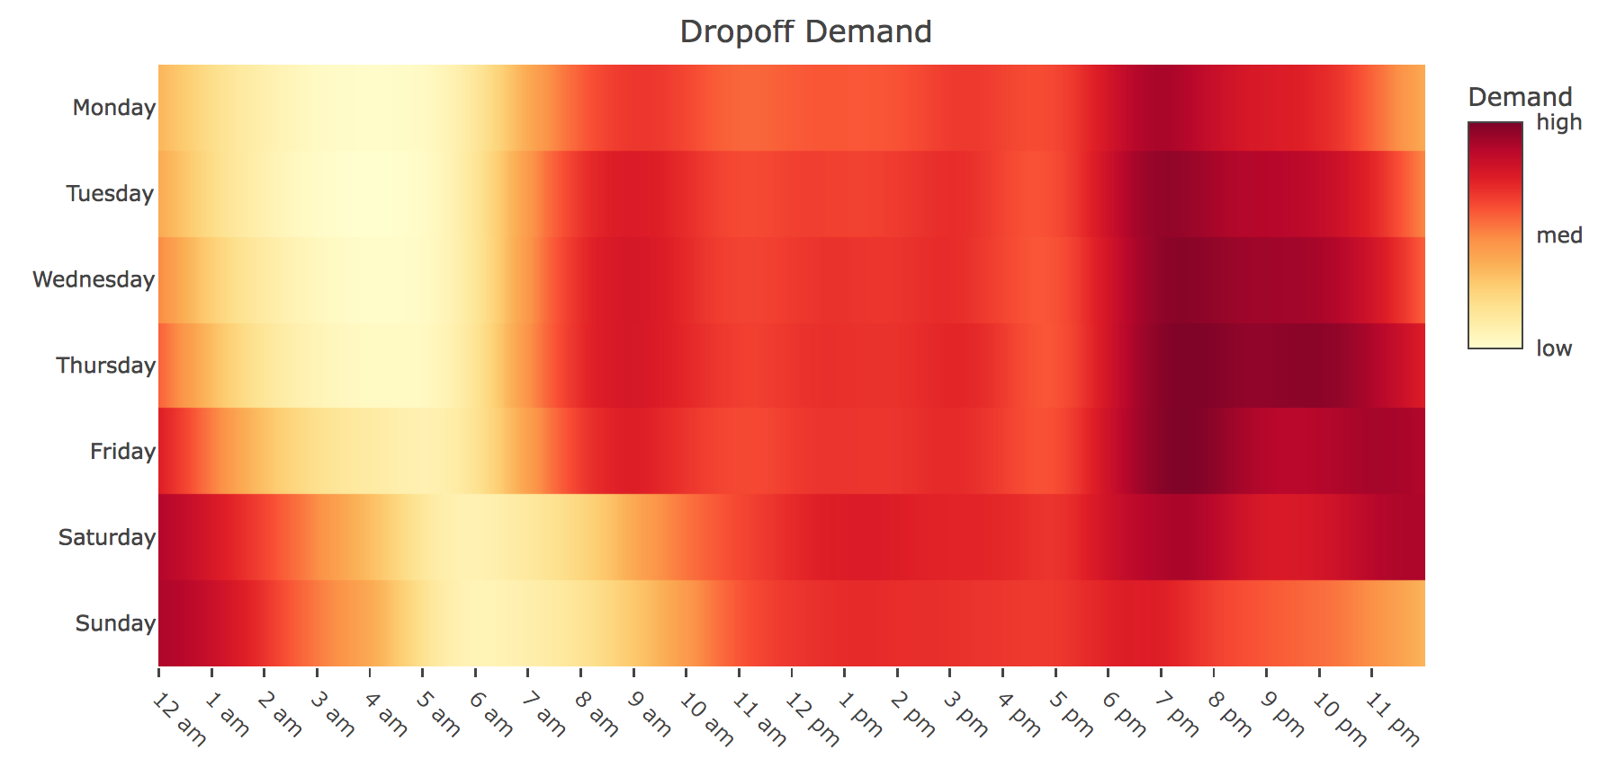

Figure 8: Dropoff Demand

We made heatmaps to estimate how the demand for taxi trips vary throughout the week and over the course of the day, and also try to compare is there any differences between Pickup Demand and Dropoff Demand. From both plots, it seems that New Yorkers tend to stay out later as the work week progresses. Moreover, among all days throughout the whole week, overall daily demand is highest on Friday.

During weekdays there is a noticeable pattern which reflects typical work schedules (9 am to 5 pm) and normal lifestyles of New Yorkers. In Figure 7, the demand for trips start picking up at 6 am and here is a small peak in demand around the start of the work day (9 am). Then there is a constant demand throughout most of the day. The demand tends to increase after 5 pm (after work) and the forms the peak that spans several hours and continues throughout the night. While during weekends, trend is different from weekdays. The morning rush hour peak (7 am to 10 am) is absent. Besides, overall daily demand is lowest on Sunday and is missing a night crowd, which might be attributed to that the next day is the beginning of the working day and people would like to stay home to save time and energy.



Figure 9: The average duration versus time of pickup

The ggplot2 package is used to visualize the data.

A sample set of “20000” is used to plot data. The duration versus time of pickup is shown above in figure 9.

**R-code:**

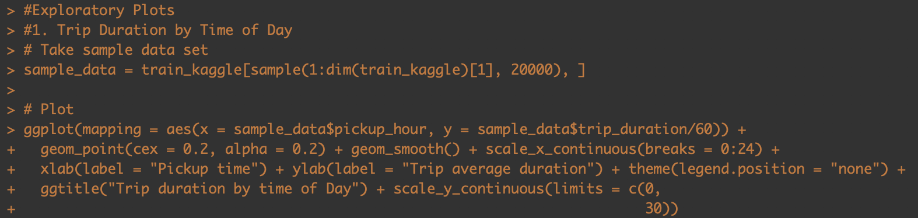

From the scatter plot above, we can deduce that time of day has a clear effect on trip duration with trips in the early morning (3 AM to 6 AM) being quicker on average.

**CLUSTERING**

Clustering is an unsupervised learning technique. It is the task of grouping together a set of objects in a way that objects in the same cluster are more similar to each other than to objects in other clusters. Clustering is mainly used for exploratory data mining. It is used in many fields such as machine learning, pattern recognition, image analysis, information retrieval, bio-informatics, data compression, and computer graphics.

**A map view of 1000 random Pickup locations using leaflet is shown below:**

Leaflet is one of the most popular open-source JavaScript libraries for interactive maps. We created a Leaflet map with these 2 basic steps:

1. Create a map widget by calling leaflet(). The function leaflet() returns a Leaflet map widget, which stores a list of objects that can be modified or updated later. Most functions in this package have an argument map as their first argument, which makes it easy to use the pipe operator %>% in the magrittr package
2. Add layers (i.e., features) to the map by using layer functions (e.g. addTiles, addMarkers) to modify the map widget.

**R-code:**

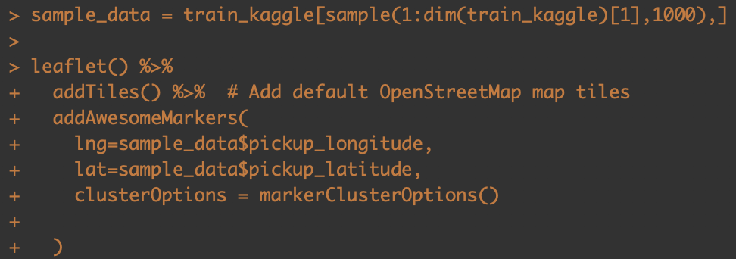

**Output:**



From this map we can see many clusters of pickup locations. Where each color tells the most popular area with most number of pickups for instance, 894 which is represented by orange color shows the highest number of pickup in particular locations and similarly 8, 9, 2, 6 represented by green color shows least range of pickup at different locations. Also, as we zoom into the map the number of clusters are divided as per the pickup locations. Each time we zoom in the plot more clusters are added to give more detailed insights similarly if we zoom out the number of clusters are reduced, and we get an overview of pickups for less locations. Overall, this can be very beneficial for cab industries as they can assign more cabs to the area which is more in demand. And grow their revenue and make some profits. Also, they can effectively manage the traffic flow smoothly.

**Map view of corresponding drop off locations using leaflet:**

Same steps are used for drop-off as we used in pick up locations.

**R-code:**

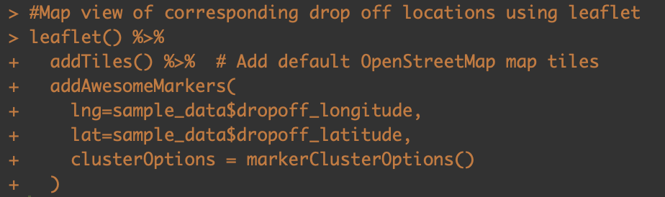

Output:



This interactive map is similar to the previous map, just the difference is that instead of pickup locations it shows drop off locations. From analyzing this the cab industry or organizations can manage the traffic flow by examining the hottest drop-off locations and can know where the most customers are going to and can smoothly manage the process.

**Clustering of pickup and drop off Locations**

So far features collected for regression include distance, time of day and month of year. In order to improve prediction accuracy, the route should be taken into account. This can be done by clustering drop off and pick up locations and including combinations as dummy variables.

First k-means clustering of pickups and drop off locations, with 10 clusters for each. Test data is included with training data for clustering to ensure test data has the cluster information available for prediction.

**Define number of clusters and Data preprocessing.**

**Cluster locations for pickup:**

**R-code:**

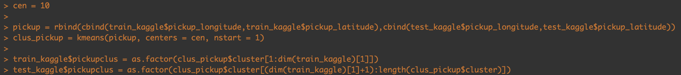

First, we define the number of clusters by giving command “cen = 10”. It’s a collective data of test and training dataset. And for creating this vector we used rbind() and cbind() on test and training dataset and given it name as “pickup” . And finally, applied clustering technique using kmean() on “pickup” vector where we group the data into 10 clusters. The kmeans function also has an “nstart” option that attempts multiple initial configurations and reports on the best one. For example, adding nstart = 25 will generate 25 initial configurations. Here we have given nstart = 1 for generating one initial configuration.

Data preprocessing: The following “train” and “test” dataset requires additional rework, in “pickup cluster” as structure of it is non-categorical and we did some recoding and convert variables to factors to treat them as categorical values.

**Cluster locations for drop-off:**

Similar to pick up, we applied all the same steps for drop-off locations too.



The pick-up and drop off locations are plotted below colored by cluster:





I choose K-means clustering because it provides a clear and straightforward visualization of the groups. And by looking at the map we can clearly visualize the most demanding pickup location and where most the customers are going too.

**LINEAR REGRESSION MODEL**

**Linear regression is used on a training set of 90% of training set. Firstly, a model is produced using only the distance variable to get a baseline idea of performance.**

**R-code:**

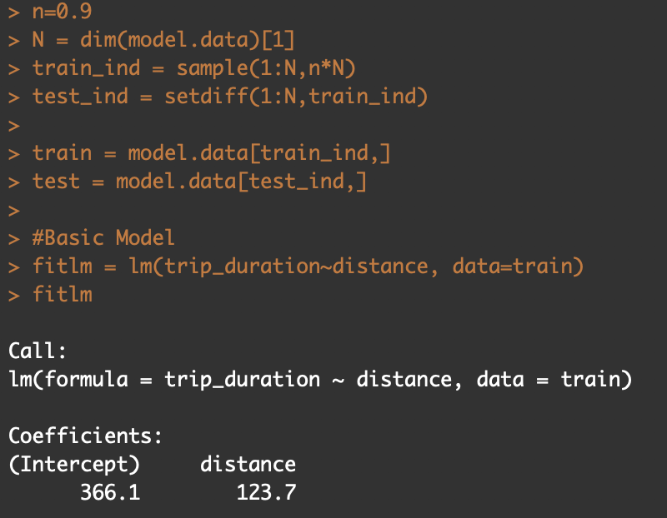

The linear model shows that the dependent variable has affected by the distance by 123 seconds approximately suggesting every distance unit adds to the trip duration by 2 minutes for the train dataset. Likewise, the dependent variable can be analyzed by all other variables calculated and the effect of them on the model can be calculated and co-related.

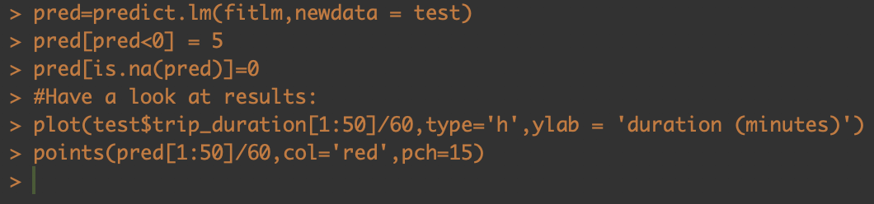

**Output:**

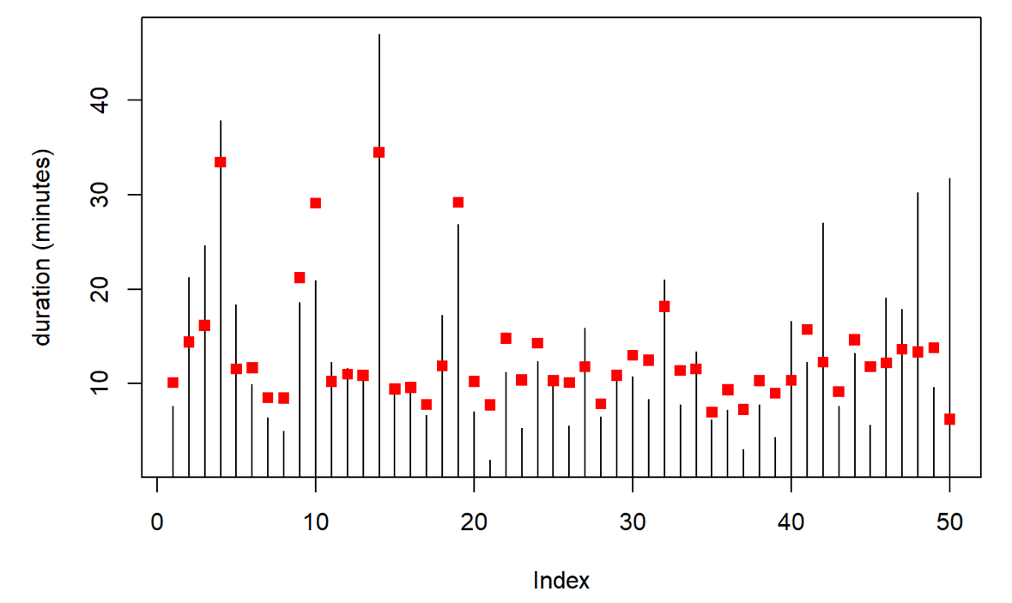

The graph shows the actual indexes calculated vs the predictors according to the trip duration. The red dot represents the predicted values and the bar lines shows the relative average values. Generally, the predictions do not appear to be very good. The model seems to have low variance, high bias (as expected for a simple linear model).

**Linear regression is now used on the full set of features, for the same set (90%).**

**R-code:**

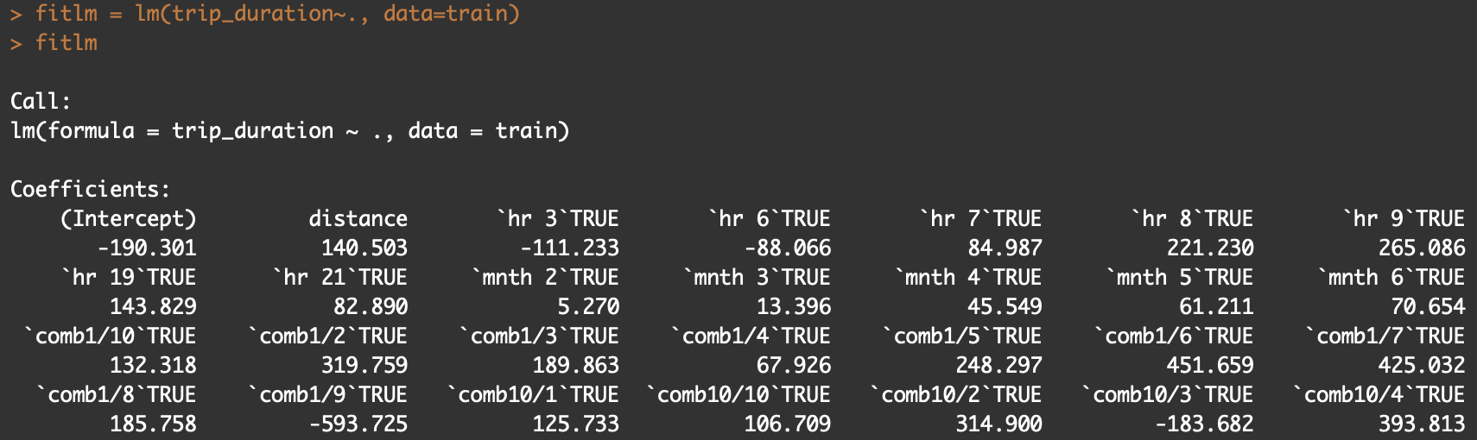

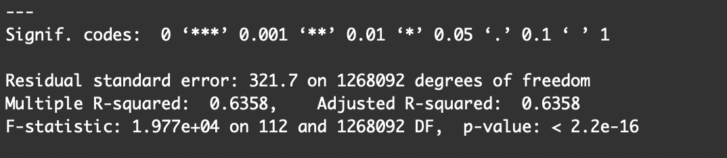

Constructing the linear model shows the effect of the independent variable over the duration, the other variables are calculated by preprocessing the data and deterring by what time and month it has taken. This provides us the ride information and linear model takes various such counts and processes a regression model. This model result shows affect to the trip duration if the ride has been takes at 3 AM it reduces the time by 111 seconds approximately, other hand 9 AM rides will cost 265 second more for each unit of distance. This suggest the less vs more rush hours can affect the duration. Such data was calculated for other variables for analysis.

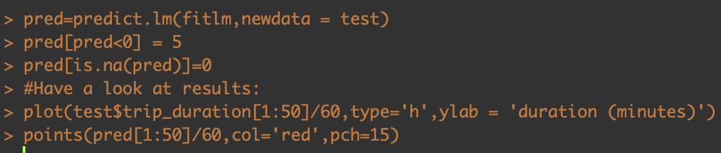

**Output:**

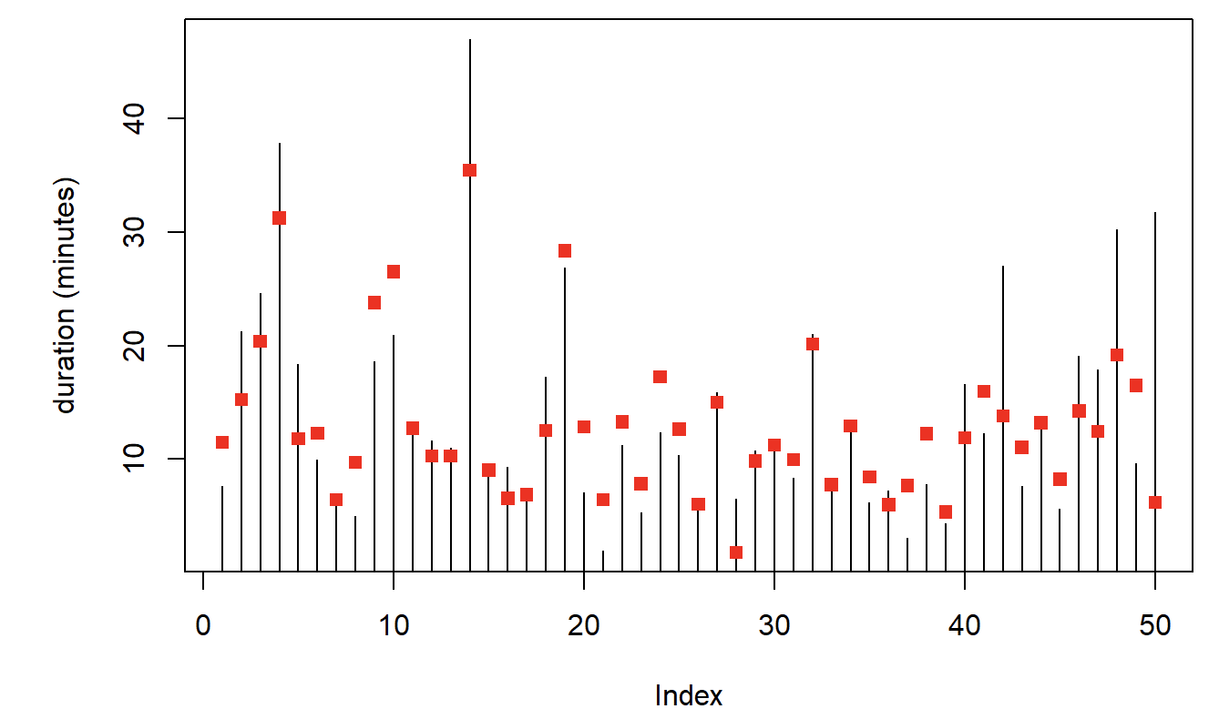

The plot shows that predictions in red generally agree with the actual duration in black, certainly outperforming the basic distance model. For the test dataset the predictors are showing the relevance with the actual values suggesting it to be a good model. The p-value of the model also shows under the significant alpha level that is less than 0.05. suggesting it to be statistically significant. R squared value hovers around 0.635 suggesting adequate variability into the model with respect to data.

**TIME SERIES ANALYSIS**

Time series analysis accounts for the fact that the data taken over time for the pickup and drop-off of New York Taxi may have an internal structure (such as autocorrelation, trend or seasonal variation) that should be accounted for. Furthermore, it can be used for forecasting and improving the Cab facility.

We have performed time series analysis on the training data.

train.csv: The training set containing 1,458,644 trip records has been converted into time series.

**Data Preprocessing:**

**R-code:**



The above code extracts the date from the pickup_datetime column and stores it in the variable train_timeseries$date1. Similarly, the pickup hour and the day of the week is extracted from pickup_datetime and stored in the variable train_timeseries$hour and train_timeseries$day respectively.

After extracting the necessary information, we have created time series on the basis of the weekly and hourly data.

**We have created a frequency distribution graph of the number of pickup rides as seen below.**

**R-code:**

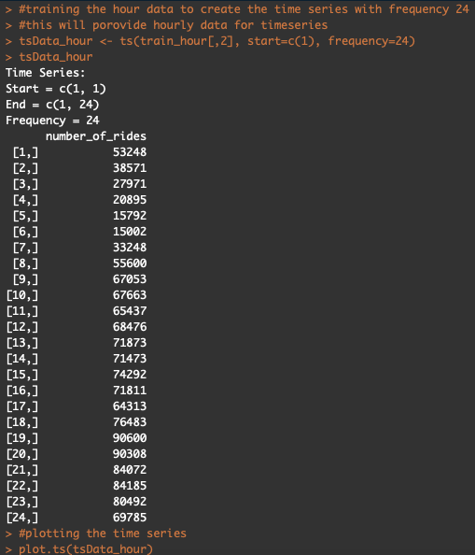

**Output:**

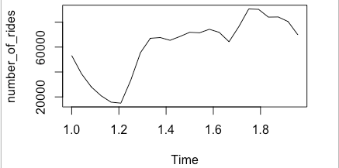

R-code:

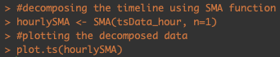

The above line of code creates the time series of the hourly data. We have used the Hours extracted from the pickup_datetime column and decomposed the data using the SMA function. The SMA() function is use to decompose the data. Decomposing a time series means separating it into its constituent components, which are usually a trend component and an irregular component, and if it is a seasonal time series, a seasonal component. As our data is non-seasonal we are using the SMA() function. To use the SMA() function, you need to specify the order (span) of the simple moving average, using the parameter “n”. For example, to calculate a simple moving average of order 1, we have set n=1 in the SMA() function. The data smoothed with a simple moving average of order 1 gives a clearer picture of the trend component and removes all the fluctuations and noise from the data.

**Output:**

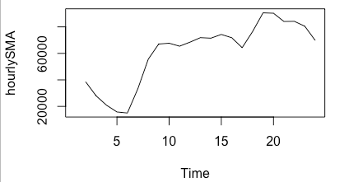

The above plot shows the time series plot of the hourly data collected over the past 6 months of the New York city. It shows hours of the day in the x axis against the number of rides in the Y axis. As we can see in the plot that the lowest number of rides is during the 5th hour of the day while people are sleeping. Then we see a drastic increase in the number of rides, the peak hour is the 10th hour of the day. This is the time when people are leaving for offices and students are leaving for schools and colleges. Again, there is demand of pickups between 17th till 20th hour of the day, that is when people are going home from offices. As seen in the graph there is a decline in the demand after 10pm till 5 in the morning.

Similarly, we have created a time series of the days of the week data. We have set the frequency to 7; where 1 represents Sunday and 7 represents Saturday.

**R-code:**

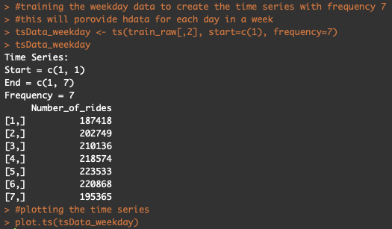

**Output:**

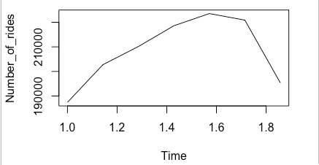

**R-code:**

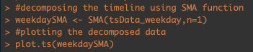

Again, as our data is non-seasonal we are using the SMA() function. To use the SMA() function, you need to specify the order (span) of the simple moving average, using the parameter “n”. For example, to calculate a simple moving average of order 1, we have set n=1 in the SMA() function. The data smoothed with a simple moving average of order 1 gives a clearer picture of the trend component and removes all the fluctuations and noise from the data.

**Output:**

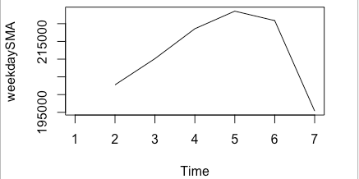

The plot represents Number of pickup rides at each day of the week. The highest number of pickup rides are on the 5th day i.e. Friday. One of the reasons behind that can be weekend party's or weekend trips. By the end of Saturday until Sunday Night there is least demand of the number of rides. Then again, the number of pickups shows an increment between Monday to Friday. Using the trend analysis, we can improvise the cab facility by finding the problems behind pickup and drop delays. In Addition, using the weekly and hourly analysis we can build a more precise model and do better path management to find the best routes for picking up and dropping off the passengers.

**RECOMMENDATIONS FOR THE ORGANIZATIONS**

For companies who would like to build taxi business in New York City, they could use this analysis as guidance to deploy their supply of taxis and control the flow of total taxis. For example, they could send more taxis in peak hour, peak day and peak month; companies could also provide more taxis in hottest pickups areas. Besides the number control of taxis, companies could arrange taxis trips in crowded locations like Manhattan or JFK airport.

For government institutions, they could take this analysis as the reference to help related departments to manage traffic conditions and adjust the route arrangement during peak time in hot areas. For example, during weekends, especially dinner time and in places that offers entertainments, there is an obvious increase of need in taxis, so organizations could control the flow on the roads on these areas in these periods ahead of time to avoid traffic jam as much as possible.

For individuals, they could use this analysis to learn more about the traffic conditions in the city where they are living in and manage their time wisely to avoid wasting too much time on the road. For example, for peak time from the center of NYC to airport, passengers should leave and make reservations of taxis earlier.

**REFERENCES**

New York City Taxi Trip Duration from <https://www.kaggle.com/c/nyc-taxi-trip-duration/data>